2）FGSM

* MNIST

|  |  |
| --- | --- |
|  | L2 Distance:  58.638947 |
|  | 49.684406 |
|  | 53.834755 |
|  | 54.681152 |
|  | 52.770157 |
|  | 43.568077 |
|  | 56.02453 |
|  | 50.098133 |
|  | 53.93727 |
|  | 44.248154 |

* Fashion MNIST

|  |  |
| --- | --- |
|  | L2 Distance:  49.731827 |
|  | 52.33737 |
|  | 52.33743 |
|  | 57.61750 |
|  | 46.305008 |
|  | 49.135406 |
|  | 52.868507 |
|  | 58.084663 |
|  | 50.613808 |
|  | 58.124342 |

* Cifar10

|  |  |
| --- | --- |
|  | L2 Distance:  58.34123 |
|  | 60.342 |
|  | 70.34234 |
|  | 40.34237 |
|  | 70.59182 |
|  | 60.23486 |
|  | 65.45893 |
|  | 58.65934 |
|  | 50.83458 |
|  | 58.485 |

Basic Iterative Method

* MNIST

|  |  |
| --- | --- |
|  | L2 Distance:  68.2348 |
|  | 69.3845 |
|  | 65.2384 |
|  | 20.459 |
|  | 54.148 |
|  | 44.349 |
|  | 34.549 |
|  | 49.4859 |
|  | 45.48235 |
|  | 33.12348 |

* Fashion MNIST

|  |  |
| --- | --- |
|  | L2 Distance:  36.150993 |
|  | 35.113922 |
|  | 32.874474 |
|  |  |
|  | 38.022118 |
|  | 29.258118 |
|  | 40.22332 |
|  | 32.052715 |
|  | 32.017265 |
|  | 33.219147 |

* Cifar10

|  |  |
| --- | --- |
|  | L2 Distance:  67.3489 |
|  | 65.34823 |
|  | 79.3458 |
|  | 68.34588 |
|  | 78.3458 |
|  | 68.3412 |
|  | 54.2913 |
|  | 32.495 |
|  | 50.1923 |
|  | 60.4903 |

Momentum Iterative method

* MNIST

|  |  |
| --- | --- |
|  | L2 Distance:  58.638947 |
|  | 49.684406 |
|  | 53.834755 |
|  | 54.681152 |
|  | 52.770157 |
|  | 43.568077 |
|  | 56.02453 |
|  | 50.098133 |
|  | 53.93727 |
|  | 44.248154 |

* Fashion MNIST

|  |  |
| --- | --- |
|  | 41.135635 |
|  | 45.73863 |
|  | 38.48382 |
|  | 41.70452 |
|  | 32.59449 |
|  | 47.682644 |
|  | 38.61961 |
|  | 34.96115 |
|  | 44.893368 |
|  | 46.37036 |

* Cifar10

|  |  |
| --- | --- |
|  | 45.4934 |
|  | 74.4539 |
|  | 34.5965 |
|  | 56.23459 |
|  | 65.3459 |
|  | 70.3495 |
|  | 69.495 |
|  | 55.546 |
|  | 34.2341 |
|  | 54.895 |

SMA

* MNIST

|  |  |
| --- | --- |
|  | L2 Distance:  58.996033 |
|  | 14 |
|  | 13.958878 |
|  | 28.186512 |
|  | 22.35225 |
|  | 40.974213 |
|  | 19.889889 |
|  | 17.790482 |
|  | 68.6289 |
|  | 10.442184 |

* Cifar10

|  |  |
| --- | --- |
|  | L2 Distance:  3.293041 |
|  | 16.619839 |
|  | 4.5920796 |
|  | 6.6491357 |
|  | 20.610796 |
|  | 3.504764 |
|  | 10.67778 |
|  | 49.69607 |
|  | 2.267498 |
|  | 2.710019 |

3)

|  |  |
| --- | --- |
| INFO 2019-03-28 02:09:01,246 cleverhans] Epoch 0 took 3.090754985809326 seconds  Test accuracy on legitimate examples: 0.9874  [INFO 2019-03-28 02:09:03,659 cleverhans] Epoch 1 took 2.1751511096954346 seconds  Test accuracy on legitimate examples: 0.9911  [INFO 2019-03-28 02:09:06,058 cleverhans] Epoch 2 took 2.1801905632019043 seconds  Test accuracy on legitimate examples: 0.9922  [INFO 2019-03-28 02:09:08,453 cleverhans] Epoch 3 took 2.1791810989379883 seconds  Test accuracy on legitimate examples: 0.9921  [INFO 2019-03-28 02:09:10,856 cleverhans] Epoch 4 took 2.1861743927001953 seconds  Test accuracy on legitimate examples: 0.9927  [INFO 2019-03-28 02:09:13,266 cleverhans] Epoch 5 took 2.19016170501709 seconds  Test accuracy on legitimate examples: 0.9931 | INFO 2019-03-28 02:10:15,908 cleverhans] Epoch 0 took 0.15755343437194824 seconds  Test accuracy on legitimate examples: 0.4475  Test accuracy on adversarial examples: 0.0904  [INFO 2019-03-28 02:10:16,555 cleverhans] Epoch 1 took 0.027937650680541992 seconds  Test accuracy on legitimate examples: 0.6874  Test accuracy on adversarial examples: 0.1605  [INFO 2019-03-28 02:10:17,100 cleverhans] Epoch 2 took 0.03090047836303711 seconds  Test accuracy on legitimate examples: 0.7274  Test accuracy on adversarial examples: 0.1691  [INFO 2019-03-28 02:10:17,637 cleverhans] Epoch 3 took 0.02994990348815918 seconds  Test accuracy on legitimate examples: 0.7605  Test accuracy on adversarial examples: 0.2014  [INFO 2019-03-28 02:10:18,183 cleverhans] Epoch 4 took 0.028951644897460938 seconds  Test accuracy on legitimate examples: 0.7675  Test accuracy on adversarial examples: 0.1940  [INFO 2019-03-28 02:10:18,709 cleverhans] Epoch 5 took 0.02991962432861328 seconds  Test accuracy on legitimate examples: 0.7957  Test accuracy on adversarial examples: 0.2253 |
|  |  |

4)

White Box Attack:

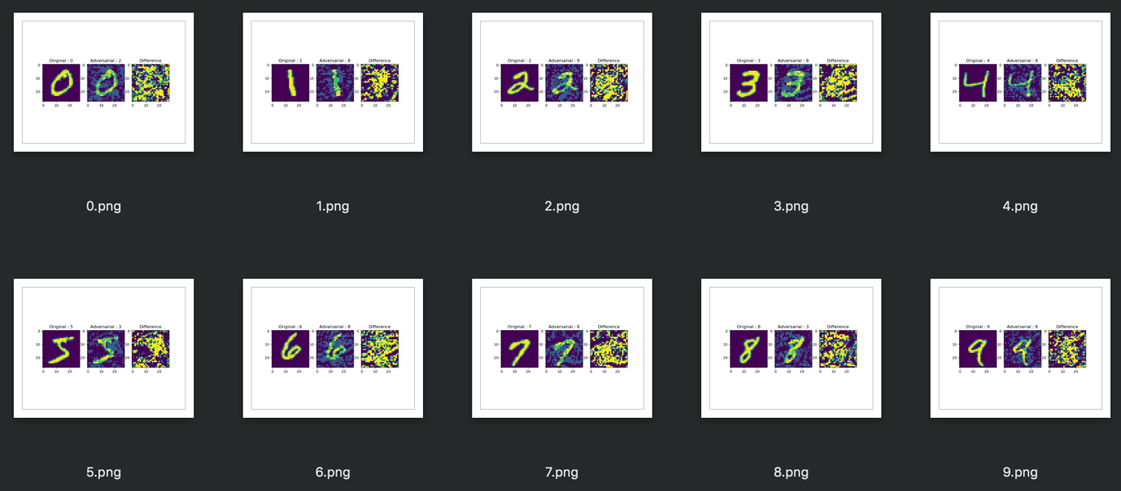

Black Box Attack:



Black box trains a local model to substitute for the target DNN, using the inputs synthetically generated by an adversary and labeled by the target DNN. As black box suggested, it has no information about the structure or parameters of the DNN, and also does not have access to any large training dataset. It can only observe labels assigned by the DNN for chosen inputs. It segregates and train a local substitute with a synthetic dataset – the inputs are synthetic and generated by the adversary while the outputs are labels assigned by the target DNN and observed by the adversary. Black box strategy is to learn the substitute for the target model using a synthetic dataset generated by the adversary and labeled by observing the oracle output. Then, the adversarial examples are crafted using this substitute. We can see that the target DNN misclassified them due to the transferability between architecture.

For the white box attack, the intruder has the access to the model’s parameters while the black box attacks the intruder has zero access to these parameters. It uses different model to generate adversarial images and run against the target model.

The results show that the white box attack using the basic iterative method achieves better results on the adversary, and also outperforms the ones with black box attack. The performance in black box attacks declined along with the number of epochs in the basic iterative method.

As shown in the figure above, the labeling between the input and the adversary does not make a significant result in the black box attack. Whereas, in the white box attack, it has introduced adversarial noises which managed to fool the classifier to make the model misclassified label.